ARCHITECTURAL WORK
IN FREECAD 0.21.2

Table of Contents
Introduction 3
Conventions And Shortcuts 6
Snap Points 9
Preferences and defaults 10
Creating Geometry 16
Trimming Lines 20
Circles 21
POLY LINE Polyline 23
Offset 23
23
24
Rectangle 25
Move 27
Drafting A Floorplan 28

Introduction
What is FreeCAD
Free CAD is a parametric 3D Modelling program with 2d Drafting capabilities. For this tutorial you will learn how to
- create 2D drafting objects and how to arrange them on a virtual paper for plotting
- create 3D models and Extract 2 projections and that can be used in plotting
3
4
5

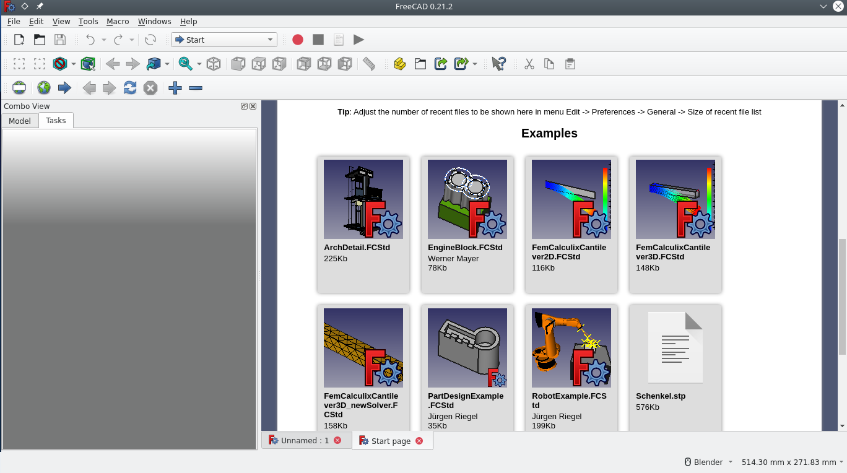

1
2

This is the starting page that appears when first starting FreeCAD . The table below explains each annotated item. (this remains the same until the settings are changed it contains sample files that show the capabilities of the software.
Menu items | Description | Tips
Combo view (1) | The combo view consists of 2 tabs; Model and tasks.  - The Model tab shows the list of current objects with subsections on data and view  - data: displays the physical properties of an object such as length  - the view tab displays the objects appearance such as line thickness and colour  - the task tab displays the current action the user is making it varies depending on the task being done.

Navigation style (2) | Displays the current ways to; pan, zoom, select and Rotate the view | Hovering the cursor of the current navigational style, displays the current mouse and keyboard commands.
Tool Bar (3) | Displays the current tools of the active work bench
Current Work Bench (4) | This displays the current work bench. Work benches are a set of tools used to perform certain tasks | The primary workbenches being used are the; Draft, Arch and Tech Draw work benches.
Drop Down Menu (5) | Standard options | It is always displayed

Work Benches
what is a work bench
A work bench is a collection of tools used to perform certain tasks. In this tutorial the work benches that will be focused on will be the draft work bench, the arch workbench and the tech draw workbench.

  Draft work bench |  | This is a collection of 2d drafting tools , including; points, lines , poly lines, circles , other geometric shapes and the means to dimension and modify them.
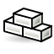  Arch work bench |  | Has some cross over with the draft work bench, it is a collection of tools that deals primarily with the creation of building components such as wall, slabs roofs and windows.
  Tech draw work bench |  | This is a collection of tools used to place 2d drawings and views of 3d objects on to a virtual representation of a paper . Here drawings from different workbenches can be scaled, rotated and further annotated.

Conventions And Shortcuts
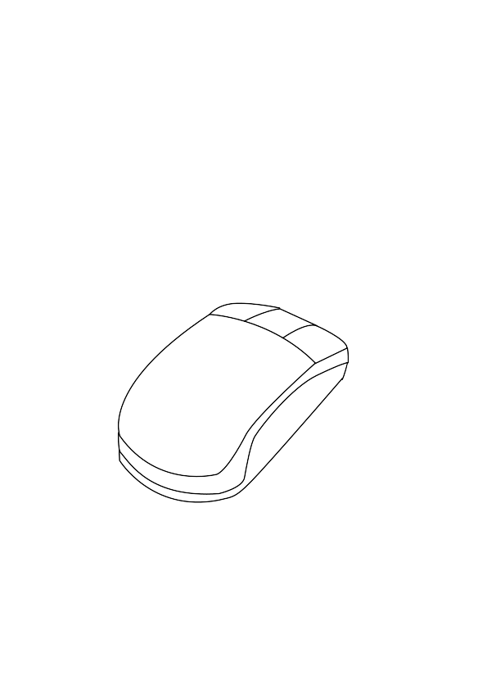  Left handed layout  middle/ orbit  options | Right handed layout
options  middle/ orbit  select | select

Function | Command | Icon | Tips
Multi select | Ctrl,+ select | -
Box select | Shift+e | - | Click once and move mouse over objects
Zoom in and out | Ctrl + middle + (move mouse) | - | These commands vary per the navigation style hovering your mouse of the current style will reveal how to navigate.
Pan view | Shift + middle (mouse move) | -
Create Point | Has no keyboard shortcut. Select it in the tool bar |  | Geometry can be created in multiple ways
Create line | Select the icon or,press ‘l’ then ‘i’ | 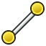 | Geometry can be created in multiple ways
Create Poly Line | Select the icon or,press ‘p’ then ‘v’ |  | Geometry can be created in multiple ways

Create circle | Select the icon or, Press ‘m’ then ’v’ , select pivot, select destination The first point determines it’s location and the second determines  its radius from that point. | 
Create ellipses | Select the icon or,  press ‘e’ then ‘l’ the first point determines it’s start and the second how long it is. | 
Create Arcs | Select the arc icon in the tool bar, there are two ways to create an arc:  selecting three points  selecting a centre and radius then two points. | 
Create Rectangle | Select the icon or, press ’r’ then ‘e’. | 
Create Polygon | Select the icon or press ‘p’ the ‘g’ | 
Create Beziér | Select the icon, you can create n curves and/ cubic curves  you may select each point manually |   
Create B- Spline | Creates a multi point B spline. You can select each point where it bends. | 

Move Object | Move an object by selecting a reference point then select a destination point (select using your mouse) | 
Rotate Object | Rotate an object using a reference point | 
Offset Object | this offsets objects depending on the position of the cursor, press ‘o’ then ‘s’ or select the icon in the tool bar | 
Mirror Object | This Mirrors an object along a line. Press ‘m’ then ‘I’ | 
Trim Object | Press ‘t’ then ‘r’  This shortens or increase the length of a line (can be a poly-line segment) |  | You may select an object before or after the comand
Hiding/Revealing An Object | Press the space Bar | -
Box Select | shift+B | 
Box Element Select | Shift+ E | 

Snap Points


Snap points exist on all geometries one creates. To activate snap points key in shift+s the snap icon will appear as shown: this indicates that snap points lock is on. Pressing shift+s turns these snap points off.
End points |  | The snaps to the end points and vertices of 3d and 2d objects
Mid point |  | This snaps to the mid point of a line
Centre |  | This snaps to the centre of a shape
Intersections |  | This snaps to intersecting, meeting or overlapping geometries
parallel | 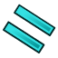 | When creating lines creates a snapping point parallel to an existing line or object
snap working plane |  | Projects snap points onto current working plane
Grid snapping |  | This snaps the cursor to points on the grid
Ortho snapping |  | This snaps the cursor to vertical, horizontal or 45 degrees when drawing geometry

Preferences and defaults
The Preferences menu displays the settings and defaults for work benches and other more General settings
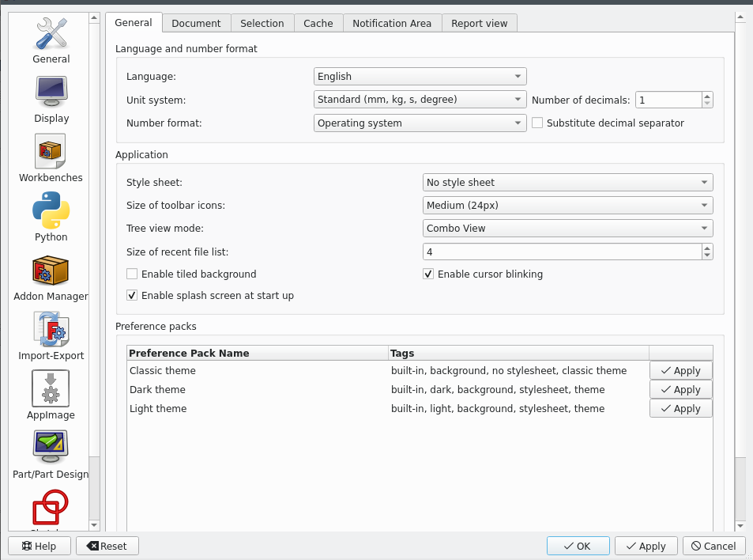
1

2

3

4
5

6

7

8

Items | Function | Tips
General (1) | For adjusting the default units and language preferences | -
Display(2) | Changes the rendering and colour settings. | For 2d drafting use a simple light grey colour for the background for good visibility.
Python(3) | Can be used to create Macros and custom commands | Macros can automate repetitive processes
Add-on Manager (4) | Can be used to add more workbenches and | Note that some work benches are still being tested
Import- Export (5) | Mainly going to be used to convert files to dxf, pdf as well as importing these file types | The c++ exporter/importer is faster but has list features that the python exporter/importer
App Image (6) | It is used to get updates for the FreeCAD | -
Work Bench options(7) | Contains a set of options unique to each work bench, such as defaults for objects. | Make sure the workbench you want to edit is active

Setting Up FreeCAD Defaults
Steps | Navigation | Reference
Ensure the Draft workbench is active  In the drop down menu | select edit>Preferences | 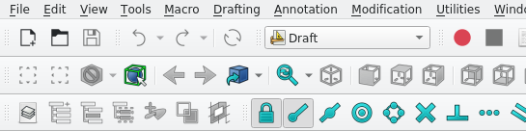
Under General select the appropriate units for this tutorial we will use the standard setting so we can draw in mm | (general>general-tab>unit system> standard(kg,mm,s, degree)) | 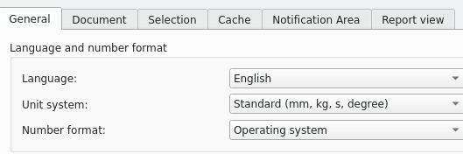
Change the Background colour from the default linear gradient to a simple colour | Edit> preferences> Display>colours> background colour> simple background colour  select the colour square and adjust it to a light grey colour | 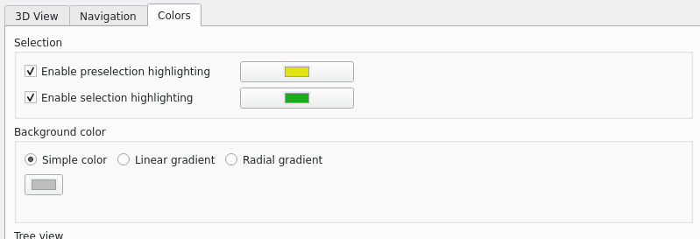

Opening and Navigating a Project
- on the drop down menu select file then open (ensure the draft workbench is selected) *select file>open>new> workbench>Draft
- select the pre-existing project Draft tutorial *specify file location documents/FreeCAD *
- the project will open
- change the work bench from part to Draft
- the numbers 1 to 5 can be used to change views
- 1 is the top view.
- You can navigate the drawing by panning and zooming (see shortcuts table)
- you can select objects with your mouse, doing so highlights them in the combo view under the model tab.
- The object can be shown and hidden by pressing the space bar
- pan by pressing middle mouse and moving the mouse (or in blender navigation mode; pan by pressing shift, holding the middle mouse button and moving the mouse)
- zoom can be used by scrolling the middle mouse button(in cad navigation) or holding shift ad the middle mouse button by moving your mouse

Active work bench
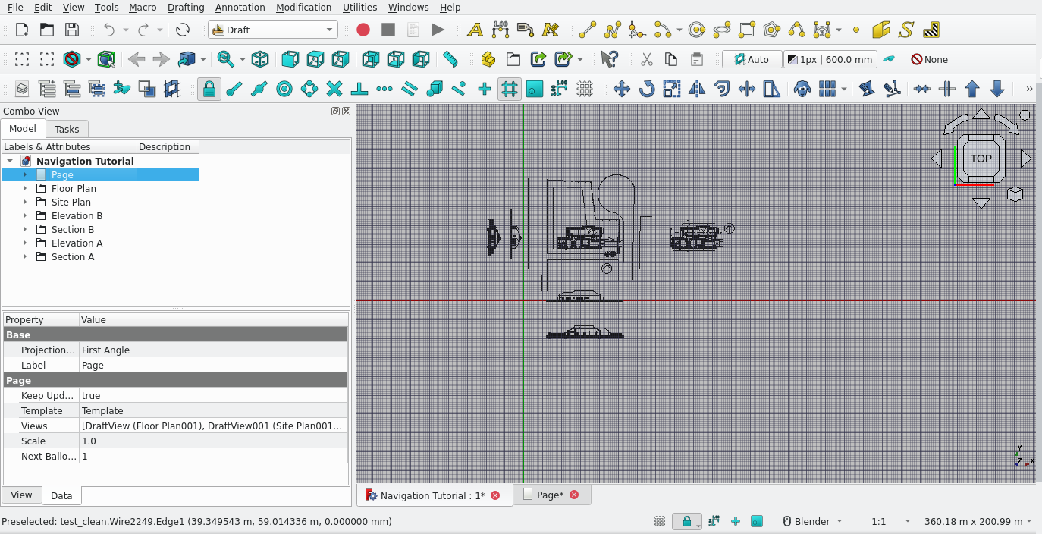

Combo view
Navigational style

Active working plane
Groups

Tasks
- zoom in on the floor-plan using either the blender(shift + middle mouse click mouse move) or cad navigational styles( mouse middle button scroll)

- select in the combo view the group called floor plan and press the space bar
- notice the entire floor plan disappears from view, pressing space bar again returns the floor plan

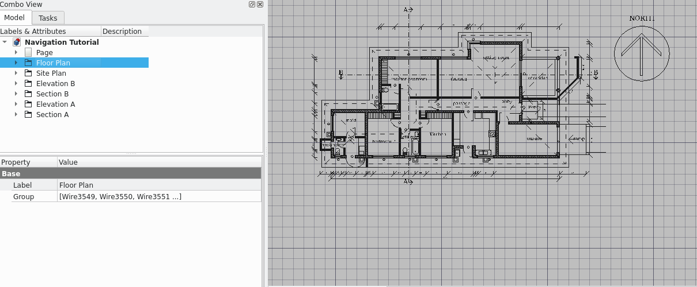
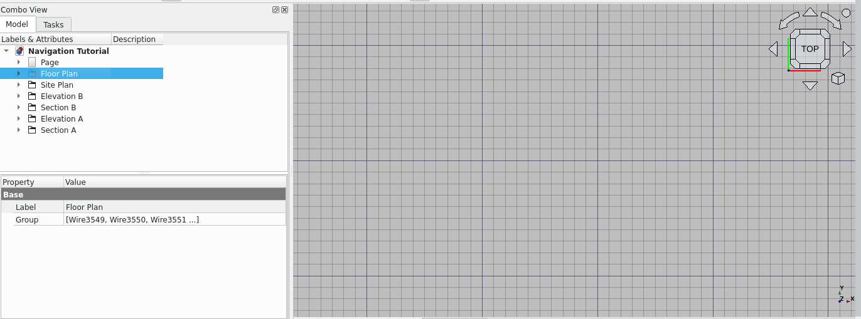
expand the groups in the combo view by selecting the arrow icon next to floorplan group

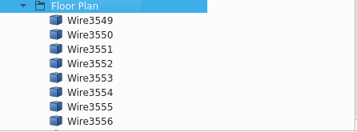

This displays all the components of said group
press space bar after selecting wire 3694 in the floorplan group
this hides the object selected
pressing space bar again unhides it

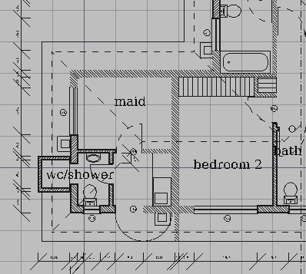
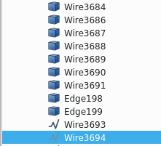

Individual elements can also be deleted
this is done by selecting the item in the combo view and pressing the delete button.
Select wire 36794 and delete it

like with other common software this can be undone simply press ctrl+z

press ctrl+z
Box select
you can select multiple objects using the box select

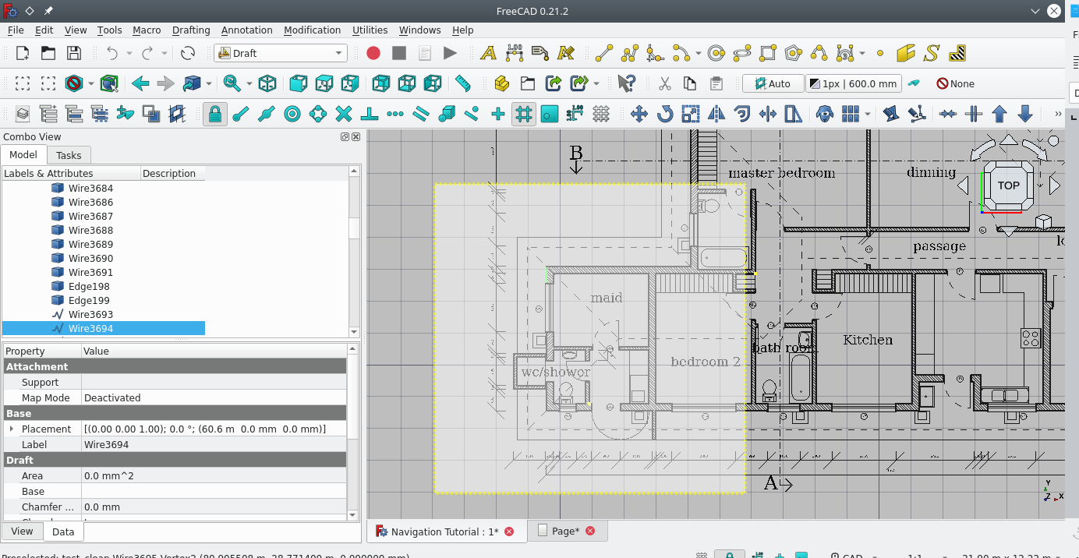

Press shift+e and the select the startingpoint: drag from the starting position to cover some of the floorplan
note that after pressing shift+r you cannon pan or zoom while box selecting
so be sure to zoom to the appropriate view
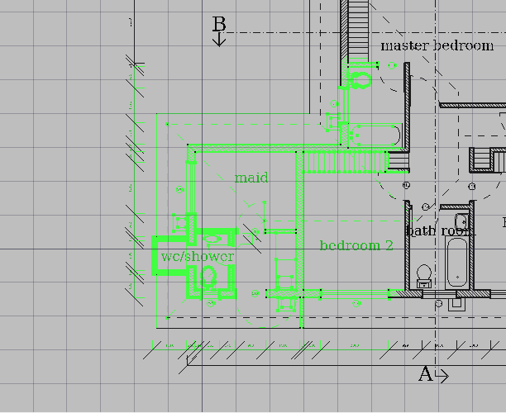
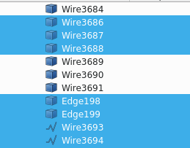

This high lights the selected objects in the combo view as well
what you have previously learned still applies
pressing space hides the selected objects and pressing space again reveals them
(note that you cannot use ctrl z to undo a hide)

you can also delete a group of selected objects

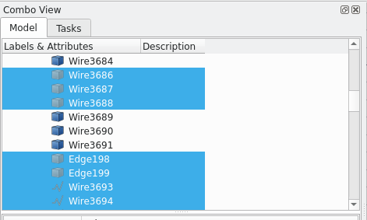
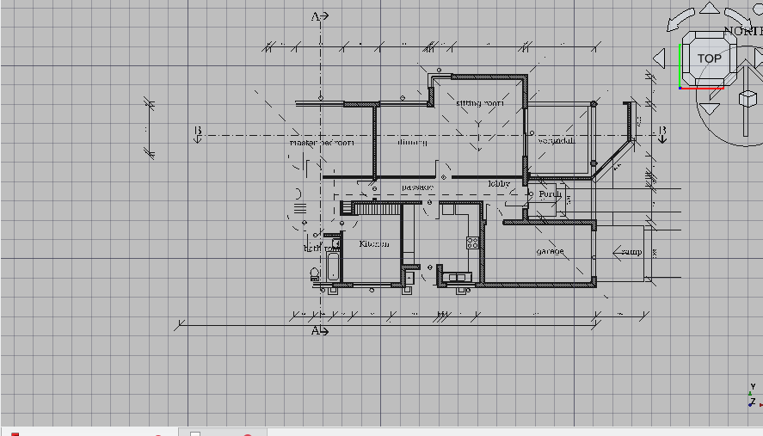

Creating Geometry

Creating documents and preparing a file  1  - Select file>new  - a new document has been created  - select the work bench button and select the draft work bench  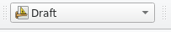  1 |  | 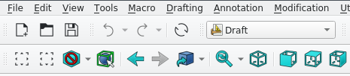  2
Snap points and views setup  - Set the view to the top by pressing 1  - turn the active working plane to top  - This ensures objects are only drawn in one plan.  - Select the point snap point  - Select snap working planes |  | 5  4
creating points  points are made by first by:  - selecting the icon in the tool bar menu  - the combo view will apear, they can be placed by either  - indicating anywhere in the drawing plane (press the select button on the mouse anywhere)  - entering coordinates in the combo task view  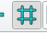  - using snap points to place it on a nother object ( in this case use the grid snap) |  | 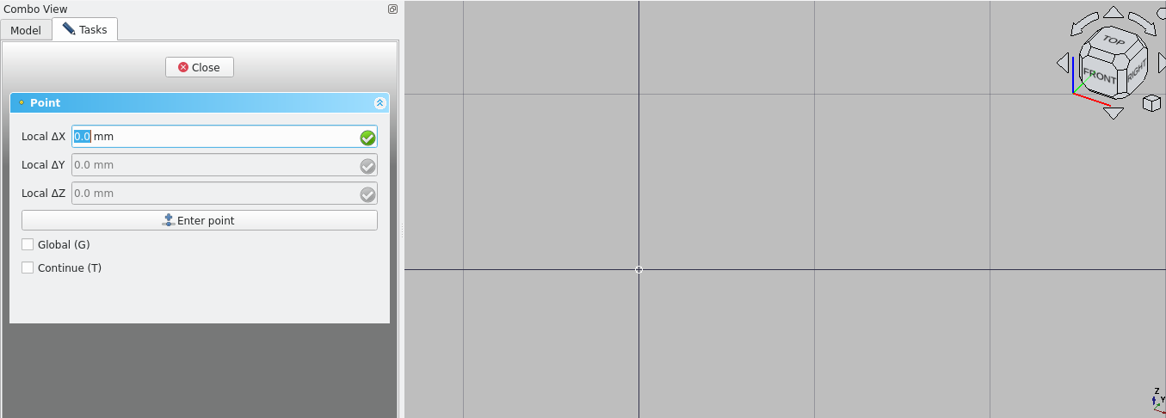  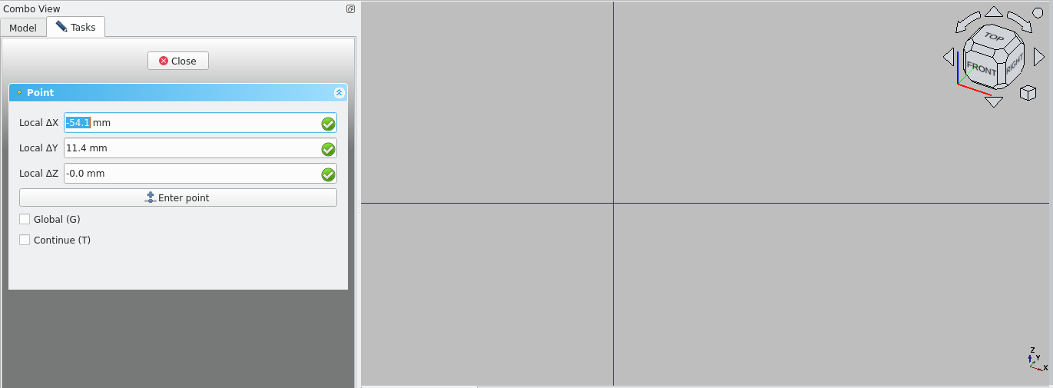
- place the point at the origin of the grid
if placing the point arbitrarily you may udjest its properties in the combo view
- select the point and set these values to zero so as to place the point at the origin

*other shortcuts for points
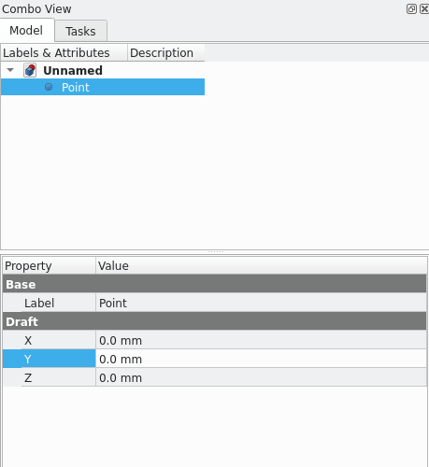
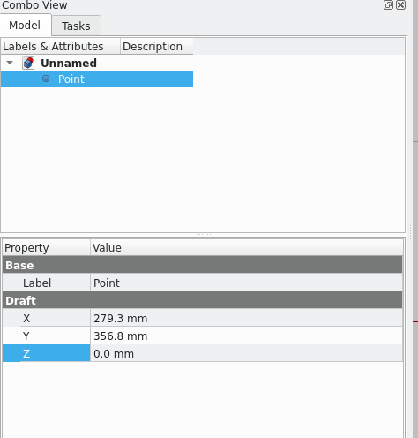
Creating lines

create a line by using shortcus; Key in l then i
the task tab in combo view apears
like with points there are three ways to create lines
inputing via combo view, abitrary placment with edits in the combo view and snap points
the first section indicates the coordinates for the start of the line the second indicates the lines length and angle
tab cycles through these options.
- Select for s 0
- press tab
- select for y and key in 0 mm
- press tab
- select for z: o
- select enter point
- press tab
- key in: 1000 mm for length
- press tab
- select angle box and key in 45
- press enter
- you have created a line at the origin at 45 degrees of length 1000 mm
- the properties of the line can be confirmed under the data tab of the combo view

some of these methods can be combined especially when objects consist of more that 2 points

- create a line intersecting with the one you drew using the same process

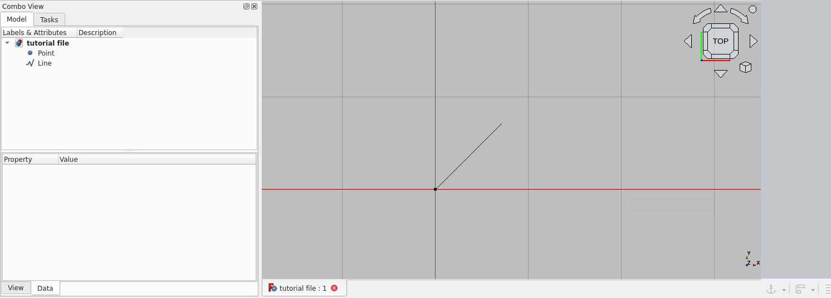
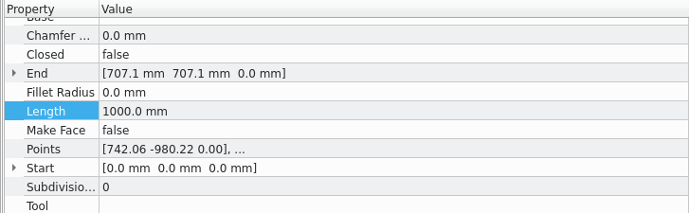
inputing via indicating
- key in li
- select a start then end point
- select the line and view it’s properties in the combo view>data adjust the properties of the length, start and end by selecting them and keying in the following;

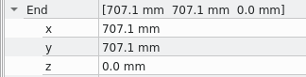 | 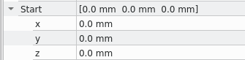
Drawing lines using snapping points
turn these snapping points on by selecting them in the tool bar
- end point
- and the snap ortho
- hover your cursor over the created point. The end point snap icon will apear to indicate that pressing select on the mouse will create the start of the line at the point
- press select on your mouse
- hover your mouse away from the point untill the ortho snap icon apears
- press selct on the mouse
- if the created line is not 1000 mm you may change it using the previous method; select the line and change the length by changing it in the combo view under data
Trimming Lines  - select the first line and key in t,r on the right side  this will open the trim dialogue options for the trim comand  moving the mouse adjusted the length of the trim manualy  however a specific distance can be keyed in  holding ctrl uses the active snaps ; snap to point snap to mid point snap to intersection etc  - trim the diagonal line  - hold ctrl (ensure the intersection snap is on by clicking on the cross shape in the snaps area)  - click select when the snap symbol apears at the lines intersection  - select the first line and key in t,r on the right side  - this will open the trim dialogue options for the trim comand  - moving the mouse adjusted the length of the trim manualy  - however a specific distance can be keyed in  - holding ctrl uses the active snaps ; snap to point snap to mid point snap to intersection etc  - trim the diagonal line  - hold ctrl (ensure the intersection snap is on by clicking on the cross shape in the snaps area)  - click select when the snap symbol apears at the lines intersection  - use this method to trim the other line so they meet at a point  - press shift e and drag the box select over both lines  - key in j,o this joins the two lines into one |  | 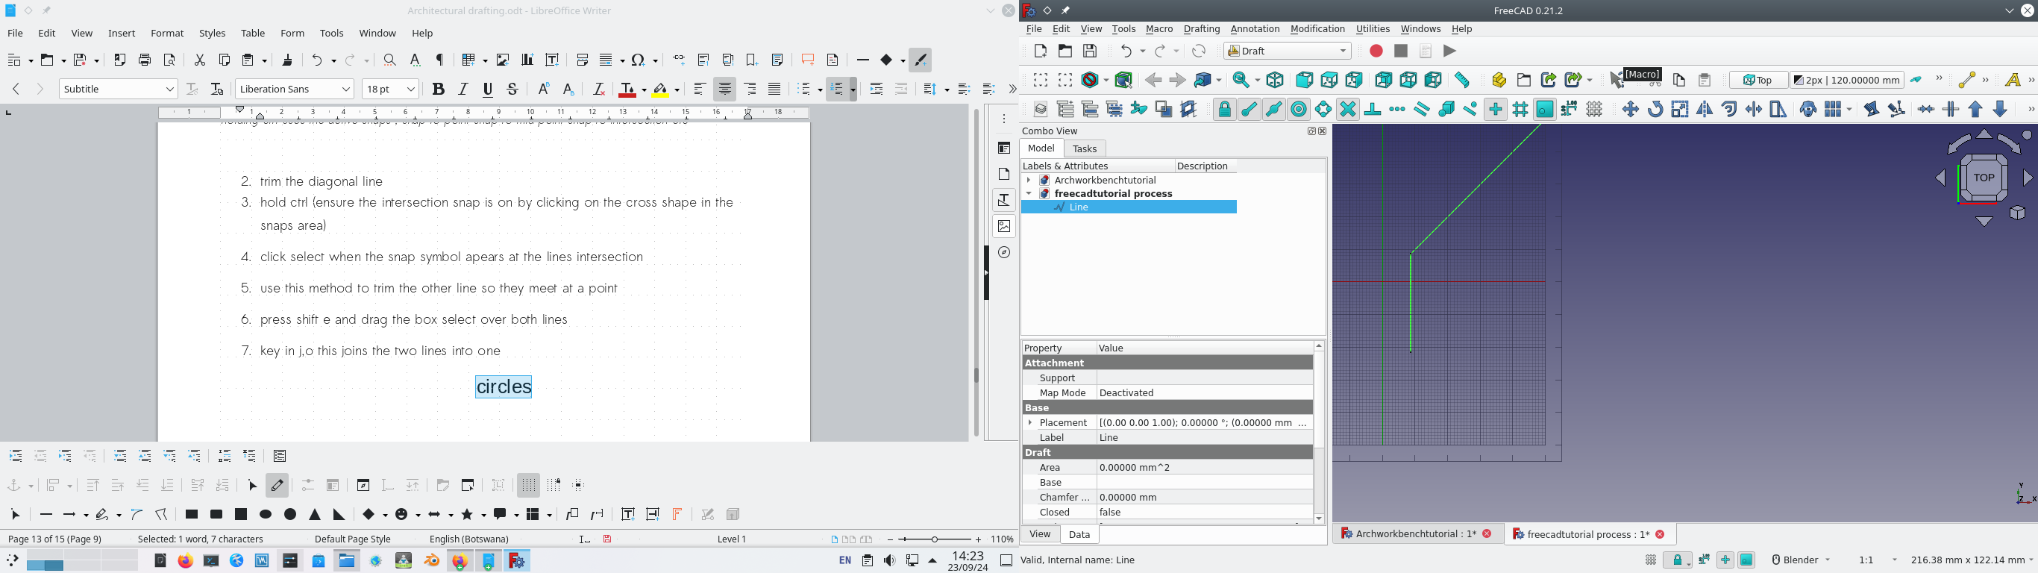

Circles
key in c,i , this starts the circle task in the combo view
as with the line command you can key where the object should start for circles
this is the centre of the circle
you can also use snaps to start it’s centre at the point where the two lines are joined
- hover your mouse over the inter section untill the snap symbol for point apears
- select it with your mouse
- key in 20 mm in the combo view
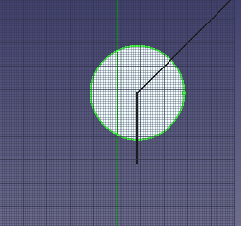
Faces are automatically generated for newly created closed geometry

- A face is created this can be removed in the combo view under the data tab
- select true next to make face and choose false (this removes the face)
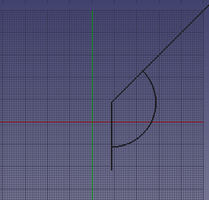
circles can also be trimmed
select the circle at the right hand side and key in t,r
- the trim task apears hold ctrl to snap the trim to the two points
the circle intersects with.

POLY LINE Polyline  - key in p,l  - this opens the poly line task  - key in 0: for the x, y and z coordinates and select enter point  - make two more segments of the poly line by snaping to points intersecting the trimed circle and line a close poly line is created |  | 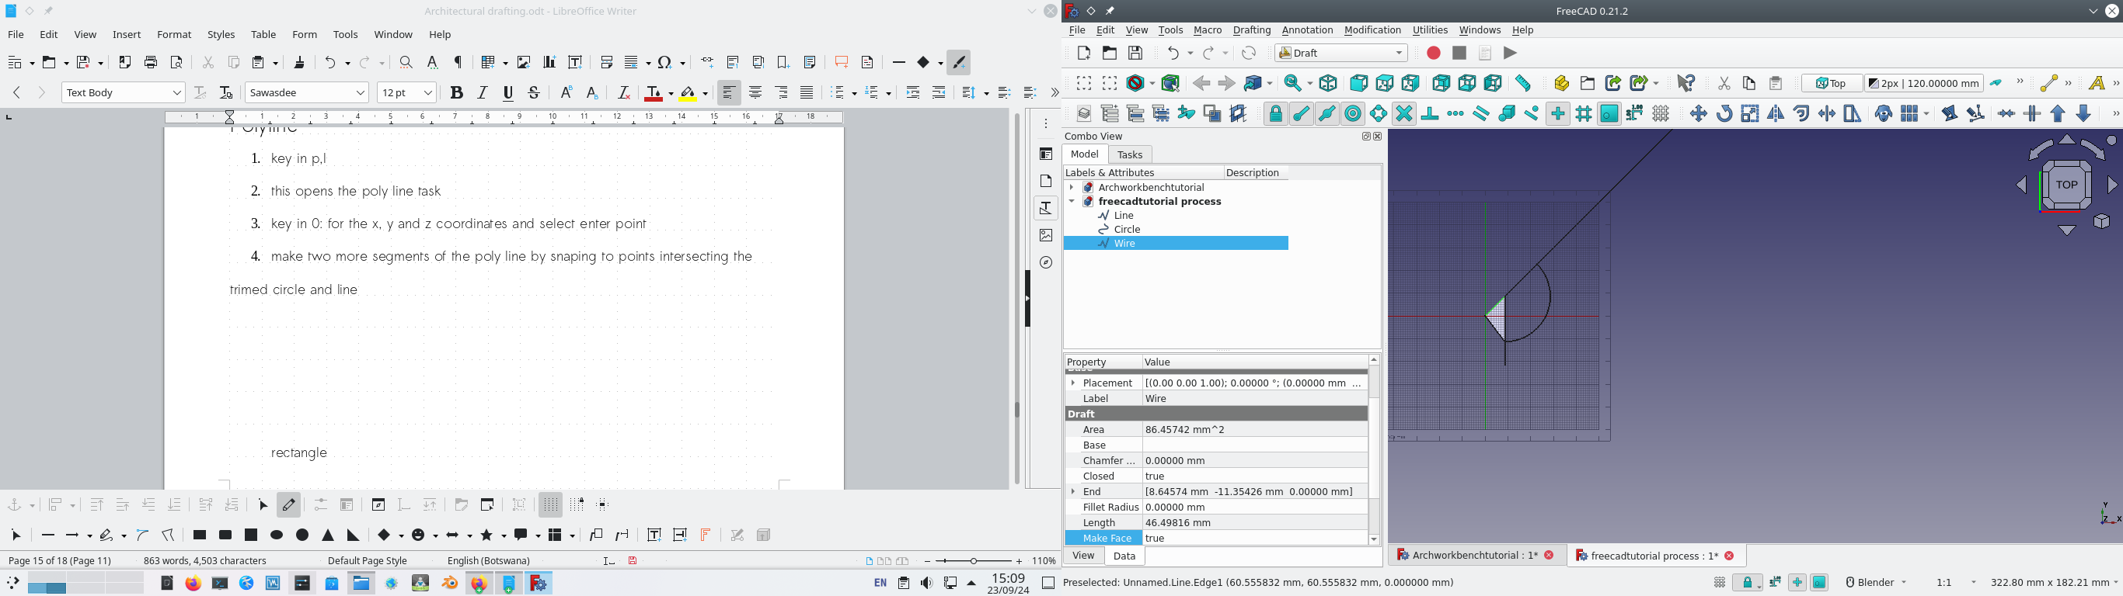
Rectangle
- key in r,e and snap the starting point to the origin and the final point to the intersection of the diagonal line and circle.

Offset
- select the line and key in o,s this open the offset task key in 20 mm
this ofsets the line by 20 mm

Rectangle

circles and other such objects can be offset as well

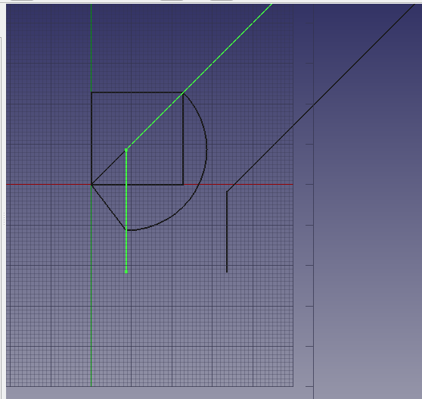
Move

Move
- click on the joined mv line, key in m,v
- the move task box apears
- key in x to restrain movement in the x axsis
- use the snap point on the right vertex of the square
- select it

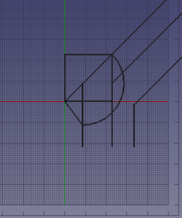

Mirror
- select the joined line on the right hand side and key in m,i
- select the middle line and snap to the the bottom point of the line
- key in y to restrict to the y axsis
- select the top point of the line

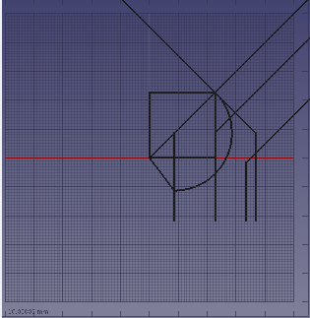

Drafting A Floorplan

In this tutorial you wil draft a 2d floorplan of the using an existing one as reference

WIP steps floorplan
importing the site
select file> import >navigate to the site folder and select the file named_____
the importer dialogue apears
*if not request change in drop down menu; edit preferences
use the c++ importer
use the options;
import
- “texts and dimensions’,
- ‘simple part shapes’
- ‘treat ellipses and splines as poly lines’,
- ‘set scale factor as units from that file to mm. If the file is in meters set it to 1000 if the file is in mm set the factor to 1.’

Drafting a floorplan

open the file_____

- select construction mode
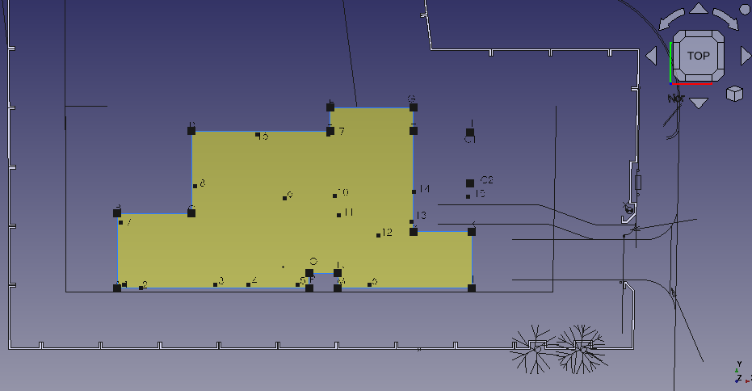
key in py and select the following points in order ; A,B,C,D,E,F,G,H,J,K,L,M,N,O,P,A to form a closed polygon (PY1)
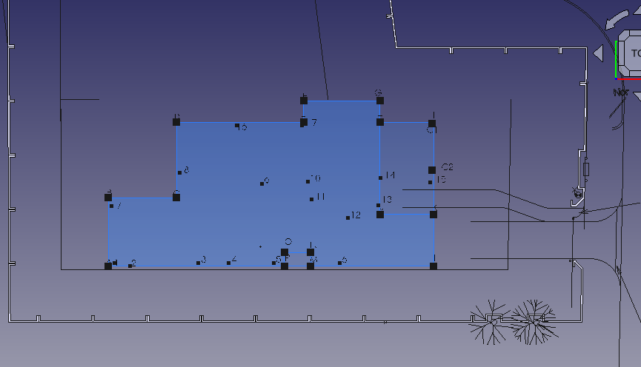
- key in py and select the following points in order; A, B, C, D, E, F, G, H, I, K,L, A
- select PY 1 sin the combo view under construction
- key in o,s, move the cursor inside the shape and key in 220 mm in the tasks tab that opened this create poly line py3
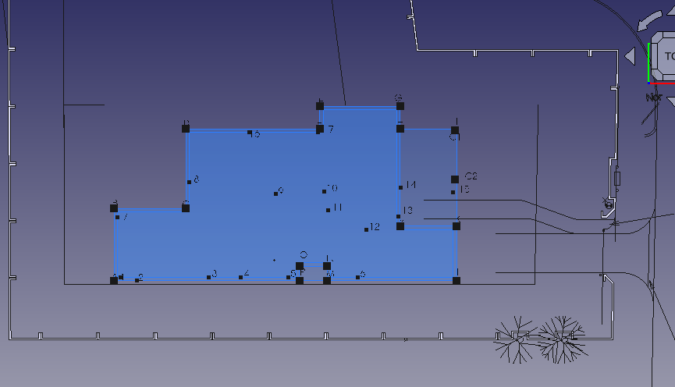
- select py 2 and key in o,s, move the cursor out side of the poly line and key in 300 mm
- select py 4 and key in o,s. Move the cursor outside of the shape, Key in 300 mm in the task tab on the right of the screen
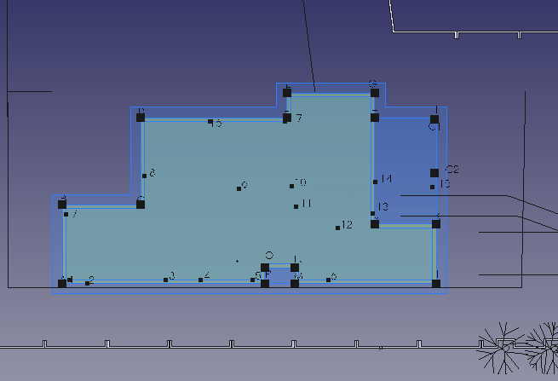

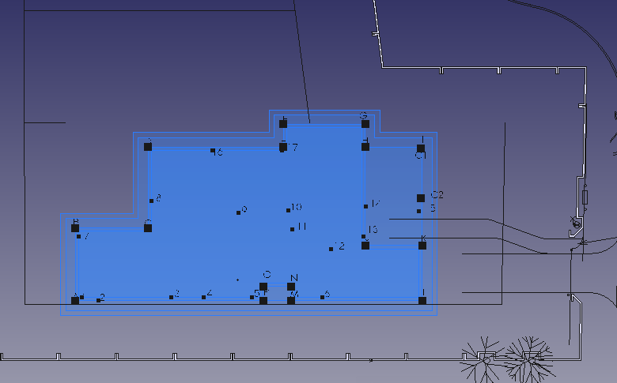
Rooms and walls
in the model view select the polylines you made and set make face to false
press shift r while the view space is at wc/shower
press shift E and select the object
key in m,v and click on the left most corner
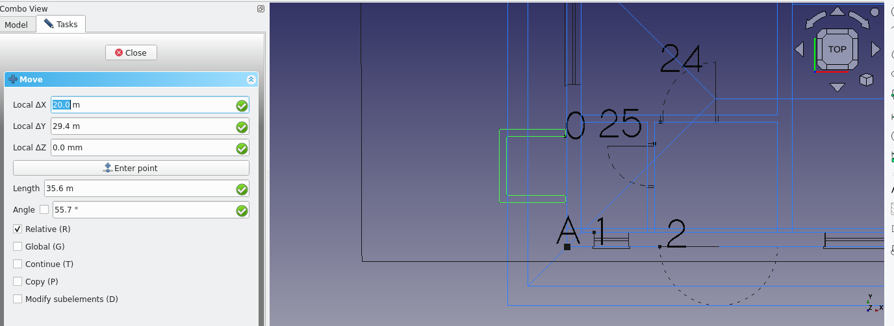
move this corner to point 0 ; key in mv, select the point and then select the destination point.
likey in r,e and create rectangles of the following dimensions (each representing the size of a room.

- WC /shower 1010 by 1690 and 1880 by 1690
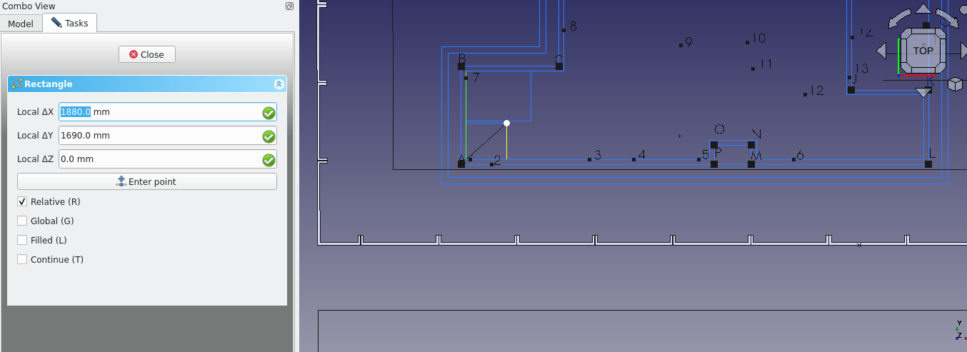
- Maid’s room ; 2300 by 3000 ( select the rectangle and key in ‘m,v’ this rectangle key in x and type in 110 mm and press the enter key
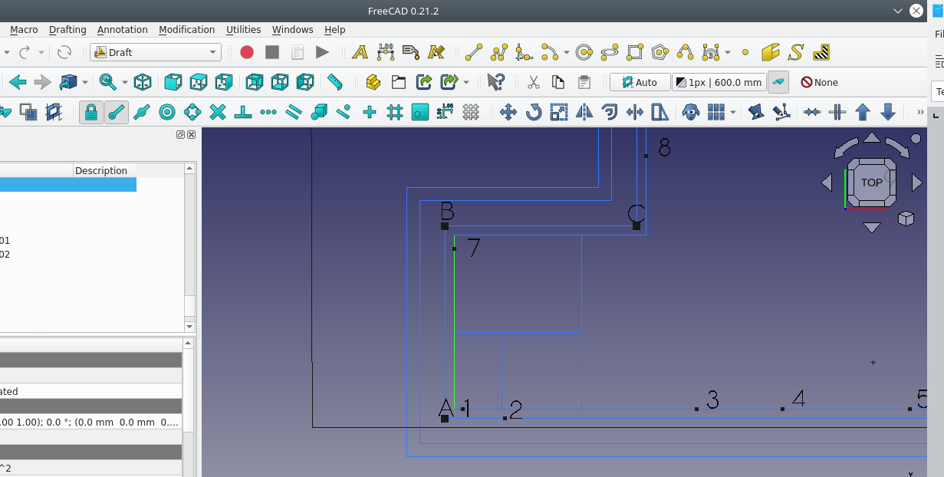
- Bedroom is 3000 by 3500 move this rectangle to the right of the maids room by 220. The walk in cupboard is 2400 by 600 and 600 by 490. move this rectangle by 110 mm to the right.
- The Bathroom is 1800 by 2400. Key in “re” enter the dimmensions and press enter. Move the rectangle 110 mm to the right; select the rectangle and key in ‘m,v’ select the bottom left corner and key in x, then enter 110 mm and hit enter.
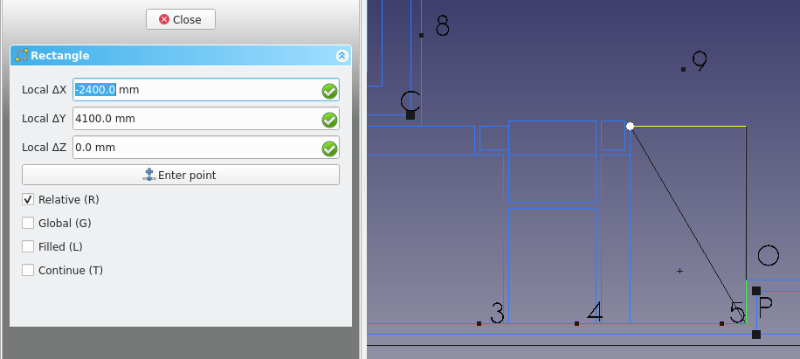
- Bedroom 2 is 3000 by 3500 the walk in cupboardreis 490 by 600 and 2400 by 600. Be sure to move the 490 by 600 rectangle 110 mm to the right.

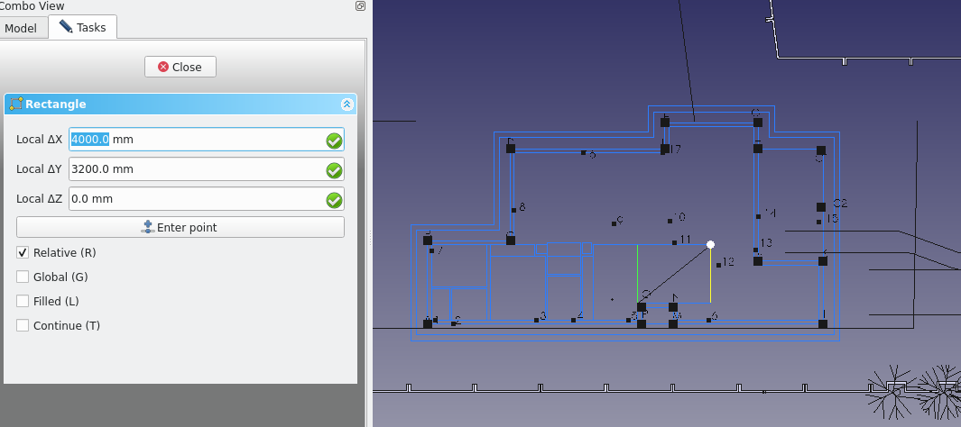
- The kitchen consists of 4000 3200 and 1945 by 900. the first rectangle should be moved to the right by 110 keu in mv and select the recangle, key in x and then 110 and press enter.
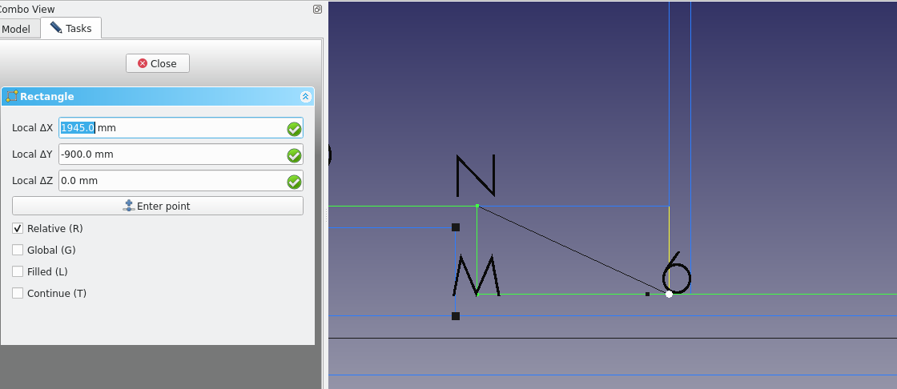
- The garage is 5560 by 3000, key in re to create the rectangle and select the starting point diagonal to I (next to the kitchen).
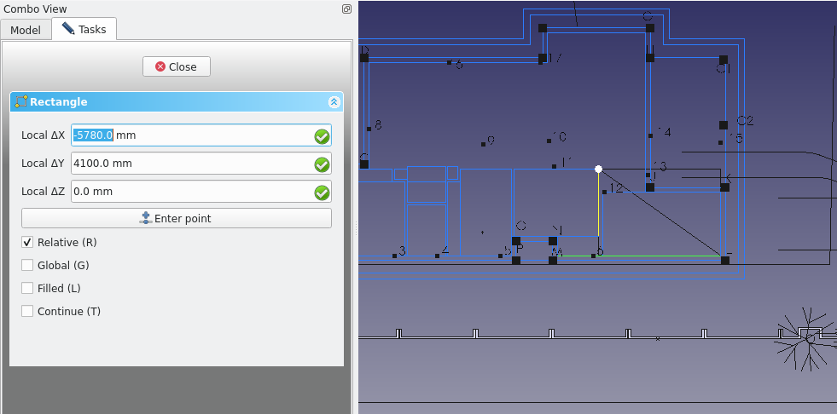
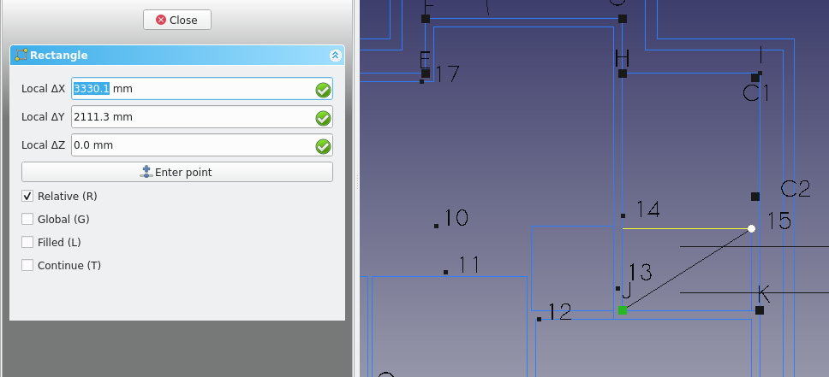
- The Porch is 3330 by 2111 and should be 110 mm above the garage
- The sitting room is 4640 by 5030 and should be placed at the point diagonal to G.( 220 in the x direction and 220 in the y direction from point G).

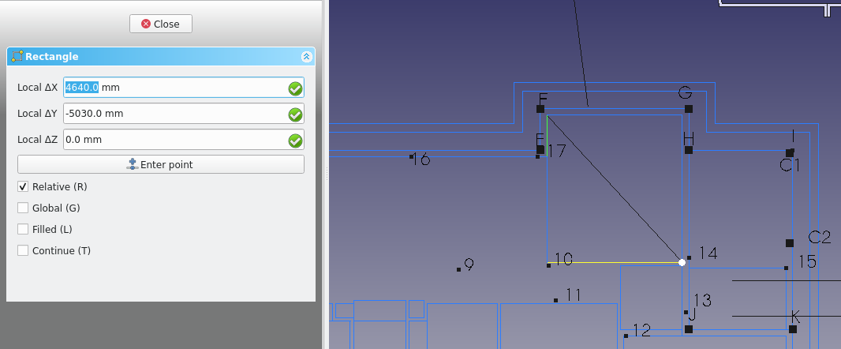
- The dining room is 3000 by 3610 and should be placed to the left of the sitting room
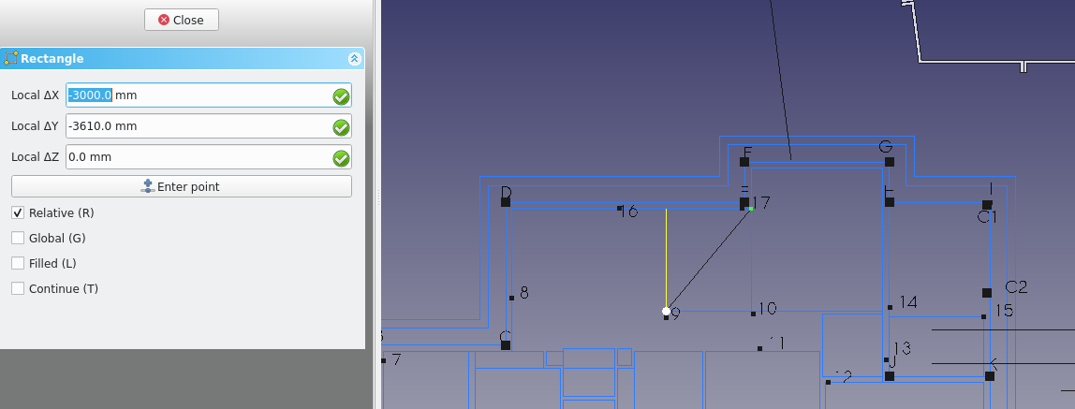
- The Master bed room 3500 by 3610 and 1810 2410
- the En suite is 1700 by 2400
- The Passage is;1800 by 990 (1800 710) (3500 1200) (5520.0 1200) and should be moved 110 mm from the ensuit
- The lobby is (2120 by 2190)
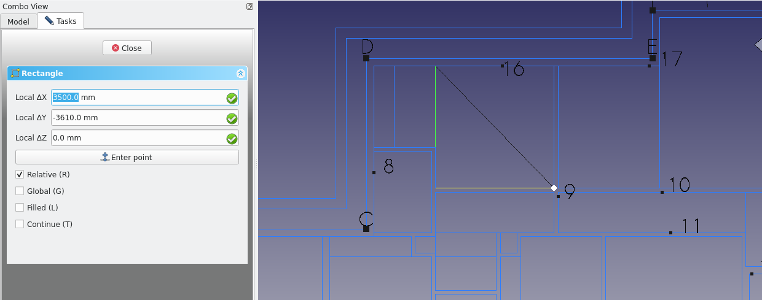

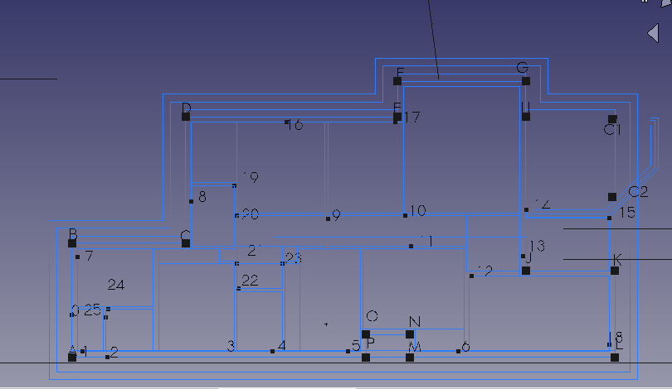

Window and door placement
at point 0 place block
at point 1 place w5
at point 2 place d14
at point 3 place w4
at point 5 place w2
70 mm from point l place d5
at point 6 place w1
at point 7 place w6
at point 9 place w7

at point 16 place w8
at point 17 place w9
at point 18 place w10
at point 19 place d10
at point 20 place d9
at point 21 place d12
at point 22 place d13
at point 23 place d11
at point 24 place d16
at point 25 place d15
at point 26 place place d3
at point 10 place d6
at point 11 place d4
at point 12 place d2
at point 13 place d1
at point 14 place d7
70 mm from point l place d5

Rooflinesmv

doors and windows
insert the window and door blocks as shown
lenghth 2000 mm , sill is 30 mm, ( 90,li 40, 90)
1996
2489
2480
15110
lm

